**A/B Testing Report**

In order to better explore whether the website content is attractive enough and meets the needs of the target users, an A/B testing is conducted with Google Analytics and Google Optimize.

Specifically, the function of viewing the upcoming theatre activities in the form of calendar is hided in the Variant B of this A/B testing. By comparing the data of the original version with the "View by Calendar" feature and Variant B without this feature (Figure 1 & 2).



Figure 1 Original Version



Figure 2 Variant B

It can be found that the original version can better meet the needs of the target users and has a better performance on most of the attributes, including the Average Time on Page, Bounce Rate, Page/Session, Average Session Duration and Experiment Bounces. The details of the data are as follows (Figure 3 - 5).

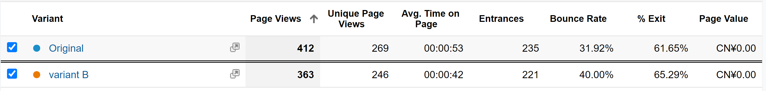Figure 3

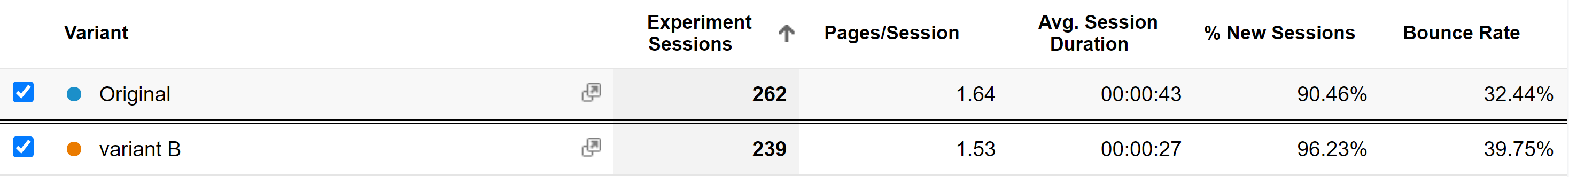

Figure 4

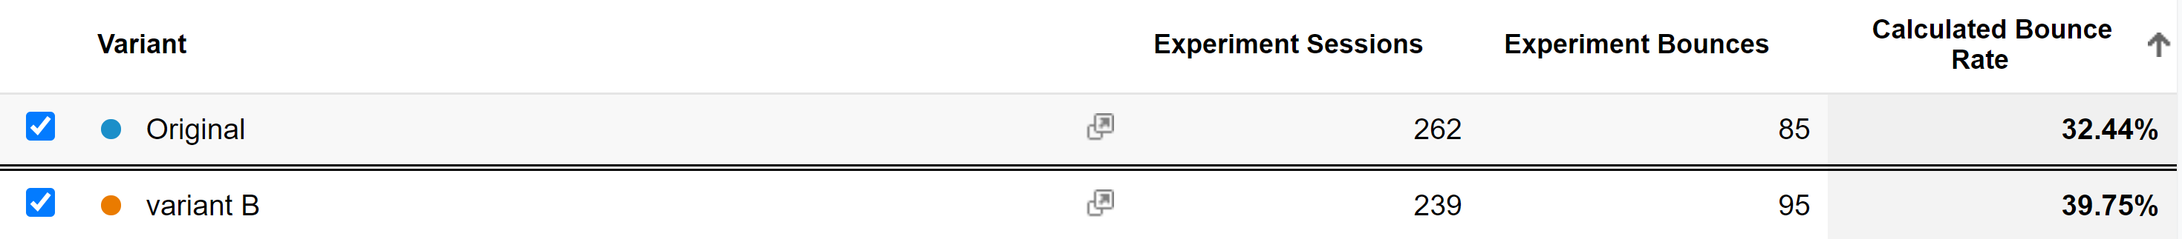

Figure 5

From these results, it can be concluded that the original version of website with calendar form is more attracting for the target users, thus gaining relatively lower Bounce Rate, higher Average Time on Page and Session Duration. Therefore, the function viewing theatre activities in the form of calendar will be remained.